## 1. General information about the website?

**Website Name:**Dr. Droid

**About the Wesite:**

An online platform to aid patients in finding the right doctors based on the symptoms they suffer from. The system suggests the best doctor considering the rating, distance and expertise. Automated appointment scheduling. Storage of patientâ€™s medical history and prescriptions allows to patients to keep track of follow up appointments easily.

**No.of web developers:** 5

**Competition:**

**1.** [www.practo.com](http://www.practo.com/)

**2.** [www.meradoctor.com](http://www.meradoctor.com/)

## 2. What to concretely expect from a website?

Dr. Droid is an online platform for doctors and pharmacists to extend the scope of their services and leverage the convenience of mobile and web technologies. Currently, Doctors and pharmacists practice their professions requiring the customer to be physically present, which limits their services to customers in a certain geographical vicinity. Our product allows the customer to book appointments and choose doctors based on rating, distance and experience, avoiding the need of physical presence for booking appointments. The app allows the patient to keep track of follow up appointments and compare the prices of the medicines from various online stores. For customers who are unable to commute to hospitals, the product provides a list of doctors who would be willing to treat them at their homes.

## 3. Which type is the website?

It’s a Web application and a Website with specific functionalities

## 4. Website structure?

**No.of webpages:** around 10

**Different page type/layout?**

* Home page
* About
* Services
* First aid
* Contact page

**Site Map:**

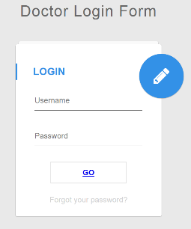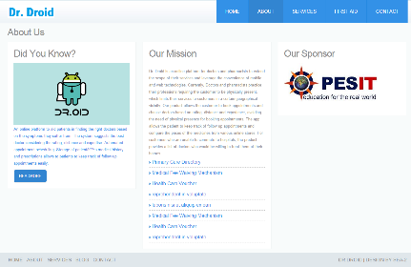

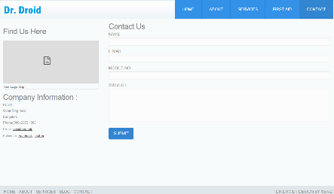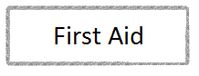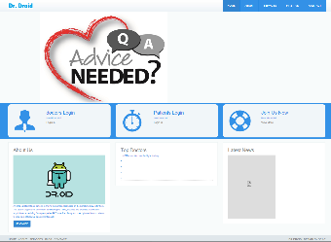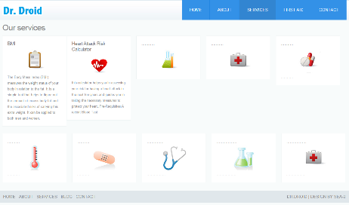

## 5. Technologies Used?

* **HTML**
* **Java Script**
* **Php**
* **Css**
* **Ajax**
* **Php Myadmin**
* **and a Web Server(apache included in wamp)**

## 6. Website functionalities?

* Doctors have to register. After the successful verification of doctor a mail will be sent and then they get access to the website After logging in users will have their profiles with these elements
* In the home page the List of Doctors with highest Rating
* Latest live News(rss feed) from medical news today
* Services to other useful medical tools like BMI, Heart Attack Risk Calculator, Dashboard for doctors, Appointments Scheduled
* A page for the basic First aid helpful to guest users
* and also a contact page for grievances and suggestions

**For Increased Performance and Responsiveness:**

* + Use of web fonts: Unlike **web** safe **fonts**, **web fonts** are not pre-installed on the user's system. The **fonts** are downloaded by the user's browser while rendering the webpage, and then applied to your text.
  + Use of Smooth transitions between pages
  + and use of google apis